Chapter8 Virtual Memory
Answers to Questions

8.1 Simple paging: all the pages of a process must be in main memory for process to run, unless overlays are used. Virtual memory paging: not all pages of a process need be in main memory frames for the process to run.; pages may be read in as needed

8.2 A phenomenon in virtual memory schemes, in which the processor spends most of its time swapping pieces rather than executing instructions.

8.3 Algorithms can be designed to exploit the principle of locality to avoid thrashing. In general, the principle of locality allows the algorithm to predict which resident pages are least likely to be referenced in the near future and are therefore good candidates for being swapped out.

8.4 Frame number: the sequential number that identifies a page in main memory; present bit: indicates whether this page is currently in main memory; modify bit: indicates whether this page has been modified since being brought into main memory.

8.5 The TLB is a cache that contains those page table entries that have been most recently used. Its purpose is to avoid, most of the time, having to go to disk to retrieve a page table entry.

8.6 With demand paging, a page is brought into main memory only when a reference is made to a location on that page. With prepaging, pages other than the one demanded by a page fault are brought in.

8.7 Resident set management deals with the following two issues: (1) how many page frames are to be allocated to each active process; and (2) whether the set of pages to be considered for replacement should be limited to those of the process that caused the page fault or encompass all the page frames in main memory. Page replacement policy deals with the following issue: among the set of pages considered, which particular page should be selected for replacement.

8.8 The clock policy is similar to FIFO, except that in the clock policy, any frame with a use bit of 1 is passed over by the algorithm.

8.9 (1) If a page is taken out of a resident set but is soon needed, it is still in main memory, saving a disk read. (2) Modified page can be written out in clusters rather than one at a time, significantly reducing the number of I/O operations and therefore the amount of disk access time.

8.10 Because a fixed allocation policy requires that the number of frames allocated to a process is fixed, when it comes time to bring in a new page for a process, one of the resident pages for that process must be swapped out (to maintain the number of frames allocated at the same amount), which is a local replacement policy.

8.11 The resident set of a process is the current number of pages of that process in main memory. The working set of a process is the number of pages of that process that have been referenced recently.

8.12 With demand cleaning, a page is written out to secondary memory only when it has been selected for replacement. A precleaning policy writes modified pages before their page frames are needed so that pages can be written out in batches.

Answers to Problems
8.1 a. Split binary address into virtual page number and offset; use VPN as index into page table; extract page frame number; concatenate offset to get physical memory address
b. (i) 1052 = 1024 + 28 maps to VPN 1 in PFN 7, (7 × 1024+28 = 7196)
(ii) 2221 = 2 × 1024 + 173 maps to VPN 2, page fault
(iii) 5499 = 5 × 1024 + 379 maps to VPN 5 in PFN 0, (0 × 1024+379 = 379)

8.2 a. Virtual memory can hold (232 bytes of main memory)/( 210 bytes/page) = 222 pages, so 22 bits are needed to specify a page in virtual memory. Each page table contains (210 bytes per page table)/(4 bytes/entry) = 28 entries. Thus, each page table can handle 8 of the required 22 bits. Therefore, 3 levels of page tables are needed.
b. Tables at two of the levels have 28 entries; tables at one level have 26 entries. (8 + 8 + 6 = 22).
c. Less space is consumed if the top level has 26 entries. In that case, the second level has 26 pages with 28 entries each, and the bottom level has 214 pages with 28 entries each, for a total of 1 + 26 + 214 pages = 16,449 pages. If the middle level has 26 entries, then the number of pages is 1 + 28 + 214 pages = 16,641 pages. If the bottom level has 26 entries, then the number of tables is 1 + 28 + 216 pages = 65,973 pages.

8.3 a. 4 Mbyte
b. Number of rows: 26+2=128 entries. Each entry consist of: 20 (page number) + 20 (frame number) + 8 bits (chain index) = 48 bits = 6 bytes.
Total: 128 × 6= 768 bytes

8.4 a. PFN 3 since loaded longest ago at time 20
b. PFN 1 since referenced longest ago at time 160
c. Clear R in PFN 3 (oldest loaded), clear R in PFN 2 (next oldest loaded), victim PFN is 0 since R=0
d. Replace the page in PFN 3 since VPN 3 (in PFN 3) is used furthest in the future
e. There are 6 faults, indicated by *

 |  | *  4 | 0 | 0 | 0 | *  2 | *  4 | 2 | *  1 | *  0 | *  3 | 2
VPN of pages in memory in LRU order | 3  0  2  1 | 4  3  0  2 | 0  4  3 | 0  4  3 | 0  4 | 2  0 | 4  2  0 | 2  4  0 | 1  2  4 | 0  1  2  4 | 3  0  1  2 | 2

8.5 9 and 10 page transfers, respectively. This is referred to as "Belady's anomaly," and was reported in "An Anomaly in Space-Time Characteristics of Certain Programs Running in a Paging Machine," by Belady et al, Communications of the ACM, June 1969.

8.6 a. LRU: Hit ratio = 16/33

1 0 2 2 1 7 6 7 0 1 2 0 3 0 4 5 1 5 2 4 5 6 7 6 7 2 4 2 7 3 3 2 3

1 1 1 1 1 1 1 1 1 1 1 1 1 1 4 4 4 4 4 4 4 4 4 4 4 2 2 2 2 2 2 2 2
- 0 0 0 0 0 6 6 6 6 2 2 2 2 2 5 5 5 5 5 5 5 5 5 5 5 4 4 4 4 4 4 4
- - 2 2 2 2 2 2 0 0 0 0 0 0 0 0 0 0 2 2 2 2 7 7 7 7 7 7 7 7 7 7 7
- - - - - 7 7 7 7 7 7 7 3 3 3 3 1 1 1 1 1 6 6 6 6 6 6 6 6 3 3 3 3
F F F F F F F F F F F F F F F F F

b. FIFO: Hit ratio = 16/33

1 0 2 2 1 7 6 7 0 1 2 0 3 0 4 5 1 5 2 4 5 6 7 6 7 2 4 2 7 3 3 2 3

1 1 1 1 1 1 6 6 6 6 6 6 6 6 4 4 4 4 4 4 4 6 6 6 6 6 6 6 6 6 6 2 2
- 0 0 0 0 0 0 0 0 1 1 1 1 1 1 5 5 5 5 5 5 5 7 7 7 7 7 7 7 7 7 7 7
- - 2 2 2 2 2 2 2 2 2 0 0 0 0 0 1 1 1 1 1 1 1 1 1 1 4 4 4 4 4 4 4
- - - - - 7 7 7 7 7 7 7 3 3 3 3 3 3 2 2 2 2 2 2 2 2 2 2 2 3 3 3 3
F F F F F F F F F F F F F F F F F

c. These two policies are equally effective for this particular page trace.

8.7 The principal advantage is a savings in physical memory space. This occurs for two reasons: (1) a user page table can be paged in to memory only when it is needed. (2) The operating system can allocate user page tables dynamically, creating one only when the process is created.
Of course, there is a disadvantage: address translation requires extra work.

8.8 The machine language version of this program, loaded in main memory starting at address 4000, might appear as:

4000 (R1) ← ONE Establish index register for i
4001 (R1) ← n Establish n in R2
4002 compare R1, R2 Test i > n
4003 branch greater 4009
4004 (R3) ← B(R1) Access B[i] using index register R1
4005 (R3) ← (R3) + C(R1) Add C[i] using index register R1
4006 A(R1) ← (R3) Store sum in A[i] using index register R1
4007 (R1) ← (R1) + ONE Increment i
4008 branch 4002
6000-6999 storage for A
7000-7999 storage for B
8000-8999 storage for C
9000 storage for ONE
9001 storage for n
The reference string generated by this loop is

494944(47484649444)1000
consisting of over 11,000 references, but involving only five distinct pages. Source: [MAEK87].

8.9 The S/370 segments are fixed in size and not visible to the programmer. Thus, none of the benefits listed for segmentation are realized on the S/370, with the exception of protection. The P bit in each segment table entry provides protection for the entire segment.

8.10 Since each page table entry is 4 bytes and each page contains 4 Kbytes, then a one-page page table would point to 1024 = 210 pages, addressing a total of 210 × 212 = 222 bytes. The address space however is 264 bytes. Adding a second layer of page tables, the top page table would point to 210 page tables, addressing a total of 232 bytes. Continuing this process,

Depth | Address Space
1 | 222 bytes
2 | 232 bytes
3 | 242 bytes
4 | 252 bytes
5 | 262 bytes
6 | 272 bytes (> 264 bytes)

we can see that 5 levels do not address the full 64 bit address space, so a 6th level is required. But only 2 bits of the 6th level are required, not the entire 10 bits. So instead of requiring your virtual addresses be 72 bits long, you could mask out and ignore all but the 2 lowest order bits of the 6th level. This would give you a 64 bit address. Your top level page table then would have only 4 entries. Yet another option is to revise the criteria that the top level page table fit into a single physical page and instead make it fit into 4 pages. This would save a physical page, which is not much.

8.11 a. 400 nanoseconds. 200 to get the page table entry, and 200 to access the memory location.
b. This is a familiar effective time calculation:

(220 × 0.85) + (420 × 0.15) = 250

Two cases: First, when the TLB contains the entry required. In that case we pay the 20 ns overhead on top of the 200 ns memory access time. Second, when the TLB does not contain the item. Then we pay an additional 200 ns to get the required entry into the TLB.
c. The higher the TLB hit rate is, the smaller the EMAT is, because the additional 200 ns penalty to get the entry into the TLB contributes less to the EMAT.

8.12 a. N
b. P

8.13 a. This is a good analogy to the CLOCK algorithm. Snow falling on the track is analogous to page hits on the circular clock buffer. The movement of the CLOCK pointer is analogous to the movement of the plow.
b. Note that the density of replaceable pages is highest immediately in front of the clock pointer, just as the density of snow is highest immediately in front of the plow. Thus, we can expect the CLOCK algorithm to be quite efficient in finding pages to replace. In fact, it can be shown that the depth of the snow in front of the plow is twice the average depth on the track as a whole. By this analogy, the number of pages replaced by the CLOCK policy on a single circuit should be twice the number that are replaceable at a random time. The analogy is imperfect because the CLOCK pointer does not move at a constant rate, but the intuitive idea remains.
The snowplow analogy to the CLOCK algorithm comes from [CARR84]; the depth analysis comes from Knuth, D. The Art of Computer Programming, Volume 2: Sorting and Searching. Reading, MA: Addison-Wesley, 1997 (page 256).

8.14 The processor hardware sets the reference bit to 0 when a new page is loaded into the frame, and to 1 when a location within the frame is referenced. The operating system can maintain a number of queues of page-frame tables. A page-frame table entry moves from one queue to another according to how long the reference bit from that page frame stays set to zero. When pages must be replaced, the pages to be replaced are chosen from the queue of the longest-life nonreferenced frames.

8.15 a.

Seq of page refs | Window Size, ∆
 | 1 | 2 | 3 | 4 | 5 | 6
1 | 1 | 1 | 1 | 1 | 1 | 1
2 | 2 | 1 2 | 1 2 | 1 2 | 1 2 | 1 2
3 | 3 | 2 3 | 1 2 3 | 1 2 3 | 1 2 3 | 1 2 3
4 | 4 | 3 4 | 2 3 4 | 1 2 3 4 | 1 2 3 4 | 1 2 3 4
5 | 5 | 4 5 | 3 4 5 | 2 3 4 5 | 1 2 3 4 5 | 1 2 3 4 5
2 | 2 | 5 2 | 4 5 2 | 3 4 5 2 | 3 4 5 2 | 1 3 4 5 2
1 | 1 | 2 1 | 5 2 1 | 4 5 2 1 | 3 4 5 2 1 | 3 4 5 2 1
3 | 3 | 1 3 | 2 1 3 | 5 2 1 3 | 4 5 2 1 3 | 4 5 2 1 3
3 | 3 | 3 | 1 3 | 2 1 3 | 5 2 1 3 | 4 5 2 1 3
2 | 2 | 3 2 | 3 2 | 1 3 2 | 1 3 2 | 5 1 3 2
3 | 3 | 2 3 | 2 3 | 2 3 | 1 2 3 | 1 2 3
4 | 4 | 3 4 | 2 3 4 | 2 3 4 | 2 3 4 | 1 2 3 4
5 | 5 | 4 5 | 3 4 5 | 2 3 4 5 | 2 3 4 5 | 2 3 4 5
4 | 4 | 5 4 | 5 4 | 3 5 4 | 2 3 5 4 | 2 3 5 4
5 | 5 | 4 5 | 4 5 | 4 5 | 3 4 5 | 2 3 4 5
1 | 1 | 5 1 | 4 5 1 | 4 5 1 | 4 5 1 | 3 4 5 1
1 | 1 | 1 | 5 1 | 4 5 1 | 4 5 1 | 4 5 1
3 | 3 | 1 3 | 1 3 | 5 1 3 | 4 5 1 3 | 4 5 1 3
2 | 2 | 3 2 | 1 3 2 | 1 3 2 | 5 1 3 2 | 4 5 1 3 2
5 | 5 | 2 5 | 3 2 5 | 1 3 2 5 | 1 3 2 5 | 1 3 2 5

b., c.

∆ | 1 | 2 | 3 | 4 | 5 | 6
s20(∆) | 1 | 1.85 | 2.5 | 3.1 | 3.55 | 3.9
m20(∆) | 0.9 | 0.75 | 0.75 | 0.65 | 0.55 | 0.5

s20(∆) is an increasing function of ∆. m20(∆) is a nonincreasing function of ∆.

8.16 [PIZZ89] suggests the following strategy. Use a mechanism that adjusts the value of Q at each window time as a function of the actual page fault rate experienced during the window. The page fault rate is computed and compared with a system-wide value for "desirable" page fault rate for a job. The value of Q is adjusted upward (downward) whenever the actual page fault rate of a job is higher (lower) than the desirable value. Experimentation using this adjustment mechanism showed that execution of the test jobs with dynamic adjustment of Q consistently produced a lower number of page faults per execution and a decreased average resident set size than the execution with a constant value of Q (within a very broad range). The memory time product (MT) versus Q using the adjustment mechanism also produced a consistent and considerable improvement over the previous test results using a constant value of Q.

8.17

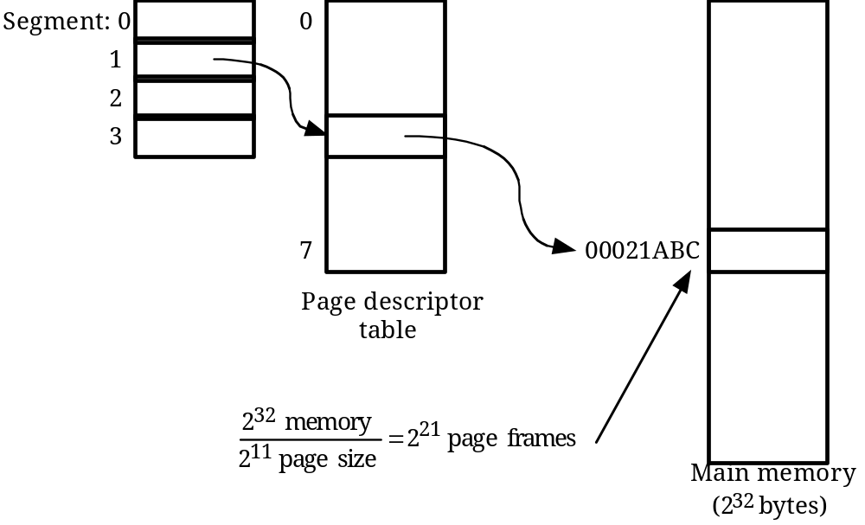

a. 8 × 2K = 16K
b. 16K × 4 = 64K
c. 232 = 4 GBytes

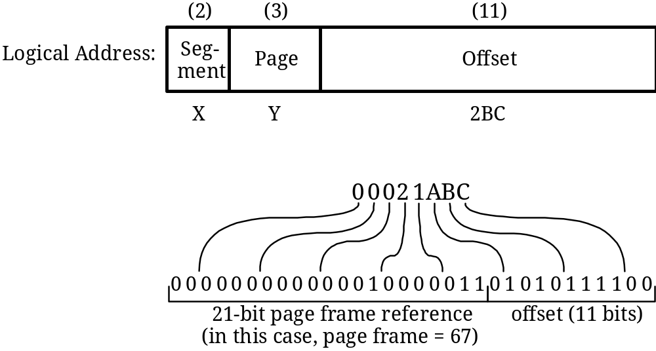

8.18 a.
page number (5) | offset (11)

b. 32 entries, each entry is 9 bits wide.
c. If total number of entries stays at 32 and the page size does not change, then each entry becomes 8 bits wide.

8.19 It is possible to shrink a process's stack by deallocating the unused pages. By convention, the contents of memory beyond the current top of the stack are undefined. On almost all architectures, the current top of stack pointer is kept in a well-defined register. Therefore, the kernel can read its contents and deallocate any unused pages as needed. The reason that this is not done is that little is gained by the effort. If the user program will repeatedly call subroutines that need additional space for local variables (a very likely case), then much time will be wasted deallocating stack space in between calls and then reallocating it later on. If the subroutine called is only used once during the life of the program and no other subroutine will ever be called that needs the stack space, then eventually the kernel will page out the unused portion of the space if it needs the memory for other purposes. In either case, the extra logic needed to recognize the case where a stack could be shrunk is unwarranted. Source: [SCHI94].

